Resource Build Template Chemistry

Resource Title: OnTRACK for College Readiness Chemistry: Quantifying Changes in Chemical Reactions: Stoichiometric Calculations
Brief Description (one to three sentences): Given descriptions or chemical formulas of reactants and products of chemical reactions, students will use molar relationships and dimensional analysis to calculate amounts of reactants and products, and to determine percent yield.

Thumbnail (file name and location): Please use the logo found in iTunes U
OnTRACK for College Readiness: Chemistry, Module 3, Lesson 8, Section 5 and 7
http://www.epsilen.com/Course/Private/Master/Index.aspx
Interactive

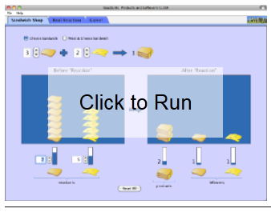

Video
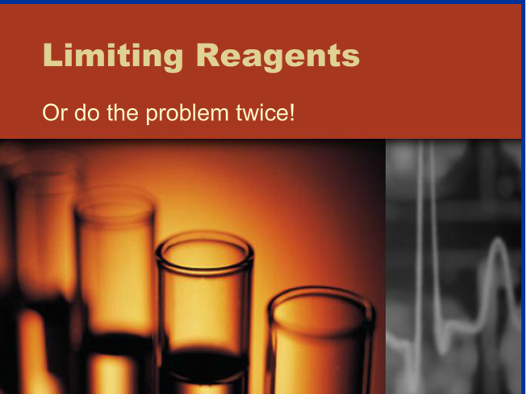

Resource Type: Interactive and Video
Audience: Teachers and students in Chemistry
Subject: Science
Grade / Course: Chemistry
Student Expectations: C.8E Science concepts. The student can quantify the changes that occur during chemical reactions. The student is expected to perform stoichiometric calculations, including determination of mass relationships between reactants and products, calculation of limiting reagents, and percent yield.

Topic / Tag: Source: stoichiometry, mass relationships, limiting reagents, percent yield
TEA Approved: Yes
License: Free and available for all public school teachers and students in Texas through TEA’s LMS portal
Content:
Label | Ownership | Type | Location (url)
Content 1 | University of Colorado | Interactive | http://phet.colorado.edu/sims/reactants-products-and-leftovers/reactants-products-and-leftovers_en.jnlp
Content 2 | TEA/University of Texas at Austin | Video | http://www.ontrack-media.net/chemistry/cm3l8ppt1.html
Related Resources:
Title | Video url | Doc url | Link
Resource 1 |  |  | http://www.sciencegeek.net/Chemistry/taters/Unit4Stoichiometry.htm
Resource 2 |  |  | http://www.chem.tamu.edu/class/majors/tutorialnotefiles/limiting.htm

