Resource Build Template Chemistry

Resource Title: OnTRACK for College Readiness Chemistry: Quantifying changes in chemical reactions- Balancing equations
Brief Description (one to three sentences): Given descriptors or chemical formulas of the reactants and the products of chemical reactions, students will apply the law of conservation of mass and manipulate coefficients to gain equal numbers of each element on either side of the reaction arrow.

Thumbnail (file name and location): Please use the logo found in iTunes U
OnTRACK for College Readiness: Chemistry, Module 3, Lesson 7, Section 1
http://www.epsilen.com/Course/Private/Master/Index.aspx
Video

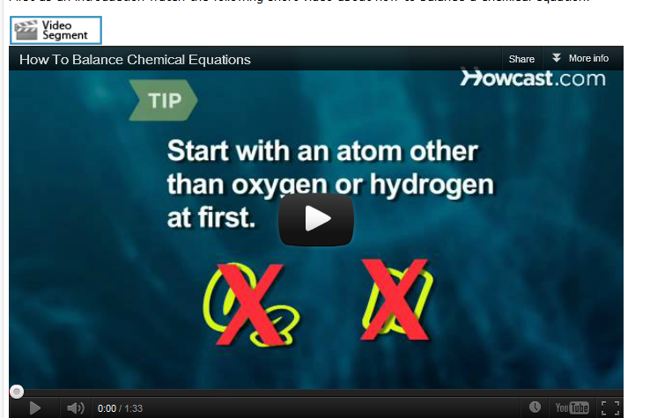

Resource Type: Video
Audience: Teachers and students in Chemistry
Subject: Science
Grade / Course: Chemistry
Student Expectations: C.8D Science concepts. The student can quantify the changes that occur during chemical reactions. The student is expected to use the law of conservation of mass to write and balance chemical equations;

Topic / Tag: chemical reaction, law of conservation of mass, chemical equation
Source: OnTRACK for College Readiness: Chemistry
TEA Approved: Yes
License: Free and available for all public school teachers and students in Texas through TEA’s LMS portal
Content: http://www.youtube.com/watch?v=8KH3laR2iR4&feature=player_embedded#t=5s
Label | Ownership | Type | Location (url)
Content 1 | You Tube | Video | http://www.youtube.com/watch?v=8KH3laR2iR4&feature=player_embedded#t=5s
Related Resources:
Title | Video url | Doc url | Link
Resource 1 |  |  | http://legacyweb.chemistry.ohio-state.edu/betha/nealChemBal/
Resource 2 |  |  | http://misterguch.brinkster.net/eqnbalance.html

