Resource Build Template Chemistry

Resource Title: OnTRACK for College Readiness Chemistry

Brief Description (one to three sentences): Given the descriptions or chemical formulas, students will use relative masses of elements in substance to calculate and determine the ratio of atoms of each element in a compound so as to determine percent composition or empirical formula.

Thumbnail (file name and location): Please use the logo found in iTunes U
OnTRACK for College Readiness: Chemistry, Module 3, Lesson 6, section #5
http://www.chemfiles.com/flash/EmpiricalFormulas.html
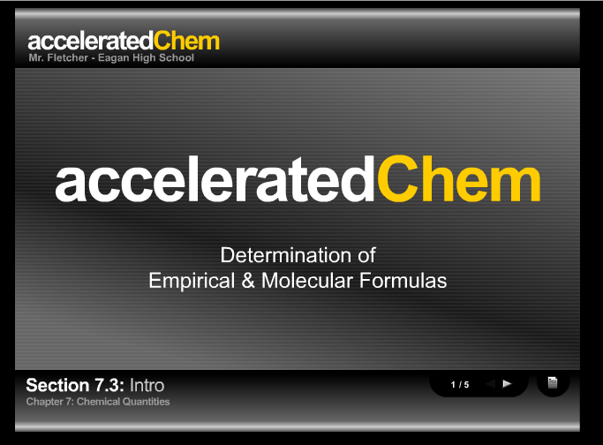

Resource Type: Video

Audience: Teachers and students in Chemistry

Subject: Chemistry

Grade / Course: Chemistry

Student Expectations: C8C calculate percent composition and empirical and molecular formulas

Topic / Tag: percent composition, empirical formulas, molecular formulas

Source: OnTRACK for College Readiness: Chemistry

TEA Approved: Yes

License: Free and available for all public school teachers and students in Texas through TEA’s LMS portal

Content:
Label | Ownership | Type | Location (url)
Content 1 | Accelerated chemistry | video | http://www.chemfiles.com/flash/EmpiricalFormulas.html

Related Resources:
Title | Video url | Doc url | Link
Resource 1 | http://www.youtube.com/watch?v=gfBcM3uvWfs&feature=fvwrel
Resource 2 |  |  | http://www.chem.tamu.edu/class/majors/tutorialnotefiles/empirical.htm
Resource 3
Resource 4

