Resource Build Template Chemistry

Resource Title: OnTRACK for College Readiness Chemistry

Brief Description (one to three sentences): Given the descriptions or chemical formulas, students will use relative masses of elements in substance to calculate and determine the ratio of atoms of each element in a compound so as to determine percent composition or empirical formula.

Thumbnail (file name and location): Please use the logo found in iTunes U
OnTRACK for College Readiness: Chemistry, Module 3, Lesson 6, section #4
http://www.youtube.com/watch?v=q41uH23pCEA
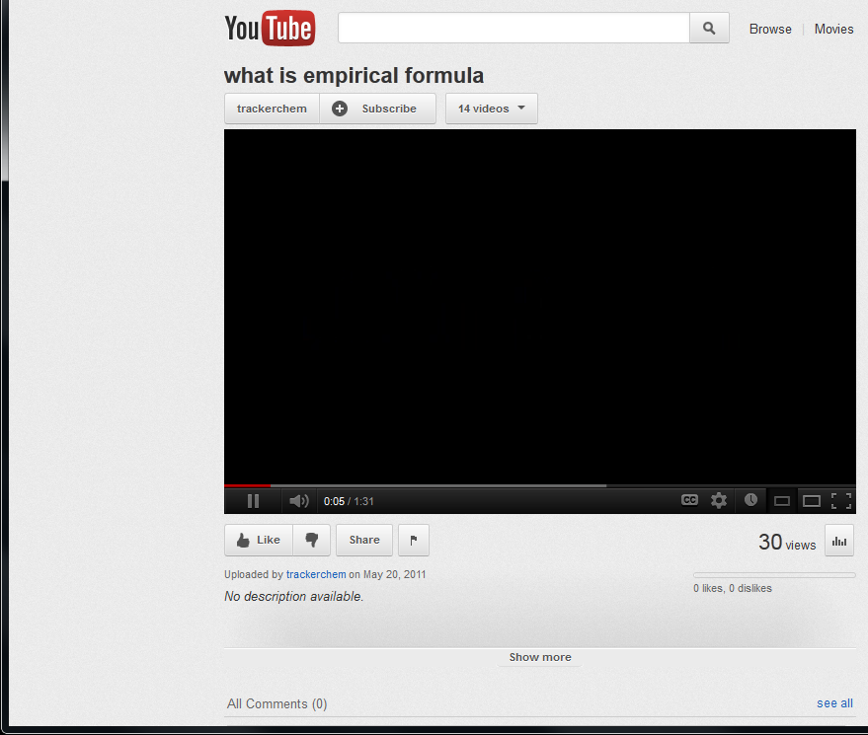
Resource Type: Video

Audience: Teachers and students in Chemistry

Subject: Chemistry

Grade / Course: Chemistry

Student Expectations: C8C calculate percent composition and empirical and molecular formulas

Topic / Tag: percent composition, empirical formulas, molecular formulas

Source: OnTRACK for College Readiness: Chemistry

TEA Approved: Yes

License: Free and available for all public school teachers and students in Texas through TEA’s LMS portal

Content:
Label | Ownership | Type | Location (url)
Content 1 | YouTube | video | http://www.youtube.com/watch?v=q41uH23pCEA

Related Resources:
Title | Video url | Doc url | Link
Resource 1 |  |  | http://science.widener.edu/svb/tutorial/empiricalformulascsn7.html
Resource 2 | http://www.youtube.com/watch?v=_H009sTvYE0&feature=relmfu
Resource 3
Resource 4

