Resource Build Template Chemistry

Resource Title: OnTRACK for College Readiness Chemistry: : Quantifying Changes in Chemical Reactions- Mole
Brief Description (one to three sentences): Given descriptions or chemical formula of a substance, students will use the atomic mass, to determine the molar mass, of the substance.

Thumbnail (file name and location): Please use the logo found in iTunes U
OnTRACK for College Readiness: Chemistry, Module 3, Lesson 5 , Section 3
http://www.epsilen.com/Course/Private/Master/Index.aspx
Html Text
Molar mass is the mass of one mole of a substance, usually expressed in grams or kilograms. Let’s say you are conducting a laboratory exercise where you are required to measure 1 mole of sulfur. Can you see yourself counting out 6.02 x 1023 atoms? If I have 1 mole of Iron, I would have 6.02 x 1023 atoms. What would be the mass of 1 mole of Iron?
Since iron has an average atomic mass from the Periodic Table of 55.8 amu, the mass of 1 mole of iron would be 55.8 grams.
What happens with diatomic molecules like hydrogen?
1 mole of H2 is still 6.02 x 1023 particles (in this case molecules) because they are joined by shared electrons.

The molar mass of a compound is found by taking the sum of the average atomic mass of each element times its subscript.
Example: 1 mole of sodium carbonate (Na2CO3) would be
2(22.99g) + 1(12.01g) + 3(15.99g) = 105.96 grams
Why?
Why do we need to know molar mass? What if you have a laboratory exercise which calls for 1 mole of manganese. You couldn't very well count out 602,000,000,000,000,000,000,000 (6.02 x1023) atoms could you? But what you can do is measure out the amount of manganese, in grams, that will give you 6.02 x 1023?

Image
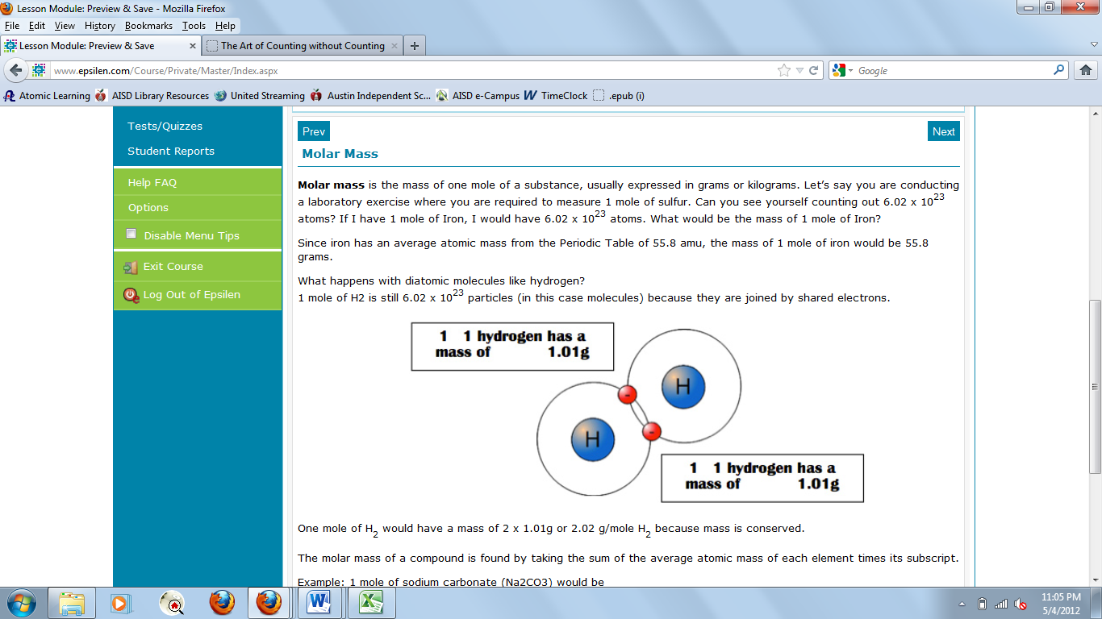
Resource Type: HTML Text and Image
Audience: Teachers and students in Chemistry
Subject: Science
Grade / Course: Chemistry 8.B Science concepts. The student can quantify the changes that occur during chemical reactions. The student is expected to use the mole concept to calculate the number of atoms, ions, or molecules in a sample of material.

Topic / Tag: chemical reaction, mole
Source: OnTRACK for College Readiness: Chemistry
TEA Approved: Yes
License: Free and available for all public school teachers and students in Texas through TEA’s LMS portal
Content:
Label | Ownership | Type | Location (url)
Content 1 | TEA/University of Texas at Austin | HTML text from Module 3, Lesson 5 , Section 3 including the image at right | http://www.ontrack-media.net/chemistry/cm3l5image8.jpg
Related Resources:
Title | Video url | Doc url | Link
Resource 1 |  |  | http://www.chemistrylecturenotes.com/html/atoms_to_mass.html
Resource 2 |  |  | http://misterguch.brinkster.net/molecalculations.html

