Resource Build Template Chemistry

Resource Title: OnTRACK for College Readiness Chemistry: Quantifying Changes in Chemical Reactions- Mole
Brief Description (one to three sentences): Given descriptions or chemical formula of a substance, students will use the atomic mass, to determine the molar mass, of the substance.

Thumbnail (file name and location): Please use the logo found in iTunes U
OnTRACK for College Readiness: Chemistry, Module 3 , Lesson 5, Section 4
http://www.epsilen.com/Course/Private/Master/Index.aspx
Video

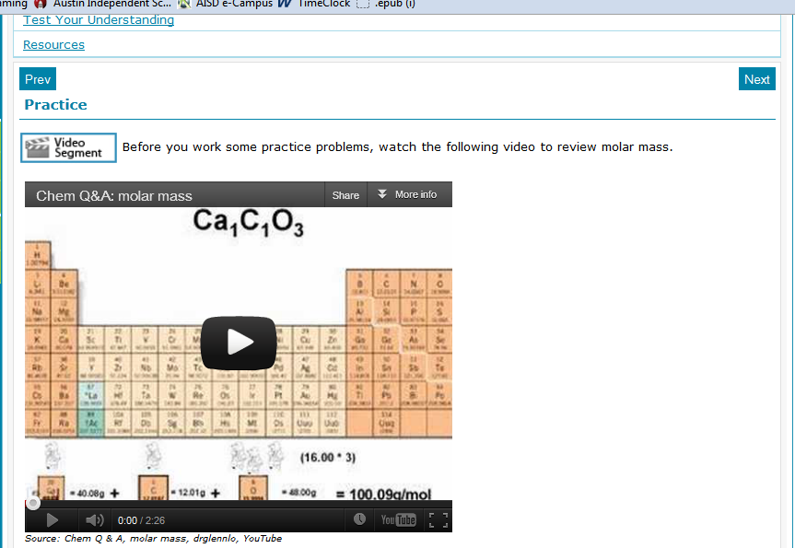

Resource Type: Video
Audience: Teachers and students in Chemistry
Subject: Science
Grade / Course: Chemistry 8.B Science concepts. The student can quantify the changes that occur during chemical reactions. The student is expected to use the mole concept to calculate the number of atoms, ions, or molecules in a sample of material.

Topic / Tag: chemical reaction, mole
Source: OnTRACK for College Readiness: Chemistry
TEA Approved: Yes
License: Free and available for all public school teachers and students in Texas through TEA’s LMS portal
Content:
Label | Ownership | Type | Location (url)
Content 1 | You Tube | Video | http://www.youtube.com/watch?feature=player_embedded&v=7Sk6kWtrcHk
Related Resources:
Title | Video url | Doc url | Link
Resource 1 |  |  | http://home.c2i.net/astandne/help_htm/english/example/chemistry-mole-calculation.htm
Resource 2 |  |  | http://www.chemistryland.com/CHM130S/07-Mole/Mole.htm

