Resource Build Template Chemistry

Resource Title: OnTRACK for College Readiness Chemistry: Thermochemical Equations
Brief Description (one to three sentences): Given descriptions, diagrams, scenarios, or chemical symbols, students will calculate the energy changes and identify exothermic and endothermic reactions.

Thumbnail (file name and location): Please use the logo found in iTunes U
OnTRACK for College Readiness: Chemistry, Module 4, Lesson 9, Section 3
http://www.epsilen.com/Course/Private/Master/Index.aspx
HTML Text 1

If you have a balanced equation you can convert between mass and energy using dimensional analysis.
Calculate the heat associated with the decomposition of 1.15g of NO2(g) according to the equation:
N2(g) + 2O2(g) → 2NO2(g) | ΔH = +67.6 kJ

Image 1

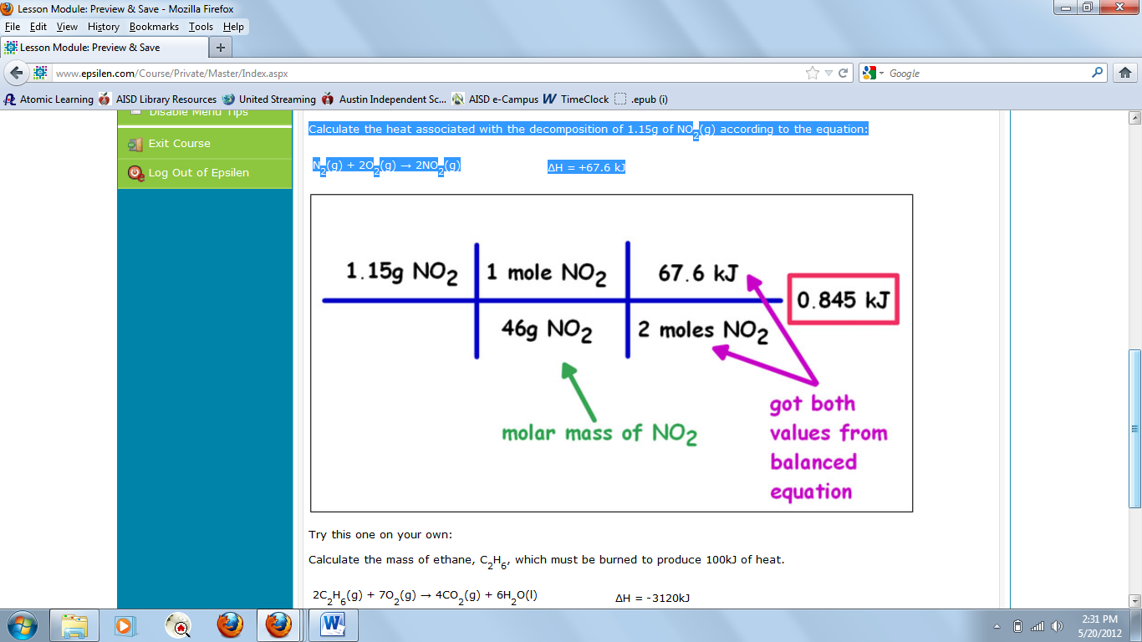

HTML Text 2

Calculate the mass of ethane, C2H6, which must be burned to produce 100kJ of heat.
2C2H6(g) + 7O2(g) → 4CO2(g) + 6H2O(l) | ΔH = -3120kJ

Image 2

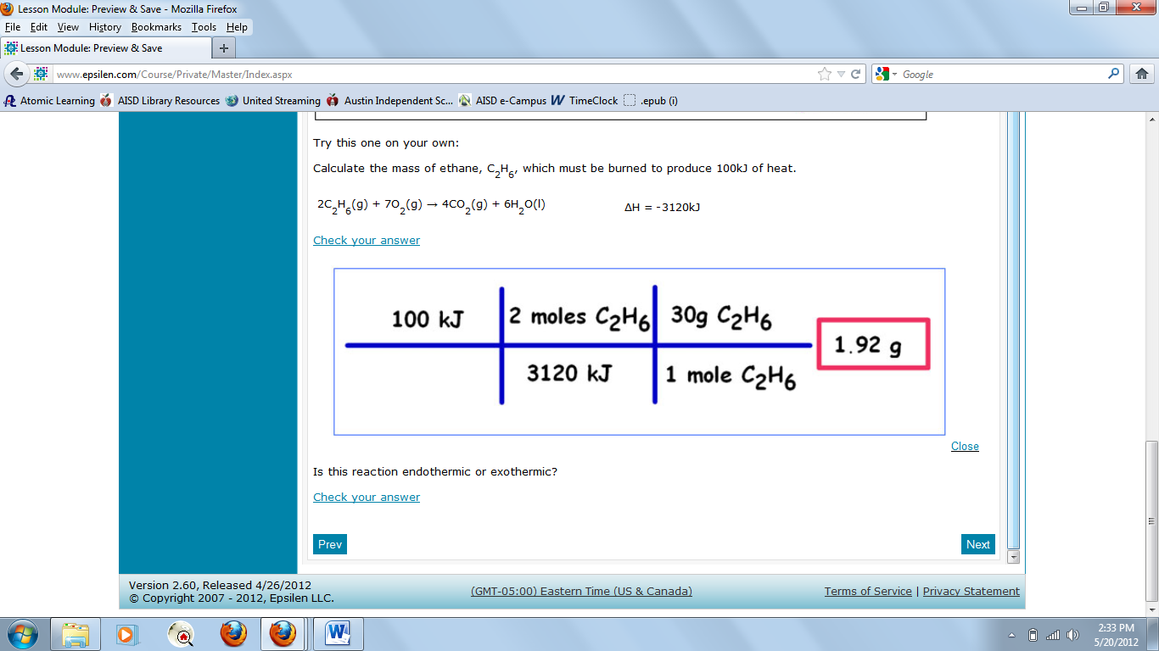

Resource Type: HTML Text and Images
Audience: Teachers and students in Chemistry
Subject: Science
Grade / Course: Chemistry
Student Expectations: C.11D Science concepts. The student understands the energy changes that occur in chemical reactions. The student is expected to perform calculations involving heat, mass, temperature change, and specific heat.

Topic / Tag: Source: energy, chemical reactions
TEA Approved: Yes
License: Free and available for all public school teachers and students in Texas through TEA’s LMS portal
Content:
Label | Ownership | Type | Location (url)
Content 1 | TEA/University of Texas at Austin | Image | http://www.ontrack-media.net/chemistry/cm4l9image3.jpg
Content 2 | TEA/University of Texas at Austin | Image | http://www.ontrack-media.net/chemistry/cm4l9image4.jpg

Resources:
Title | Video url | Doc url | Link
Resource 1 | http://www.youtube.com/watch?feature=player_embedded&v=PU0bdFrwrec#t=0s
Resource 2 | http://www.youtube.com/watch?v=vgh76gPSg3M&feature=player_embedded#t=0s

