Resource Build Template Chemistry

Resource Title: OnTRACK for College Readiness Chemistry: Thermochemical Equations
Brief Description (one to three sentences): Given descriptions, diagrams, scenarios, or chemical symbols, students will calculate the energy changes and identify exothermic and endothermic reactions.

Thumbnail (file name and location): Please use the logo found in iTunes U
OnTRACK for College Readiness: Chemistry, Module 4, Lesson 9, Section 2
http://www.epsilen.com/Course/Private/Master/Index.aspx
Interactive
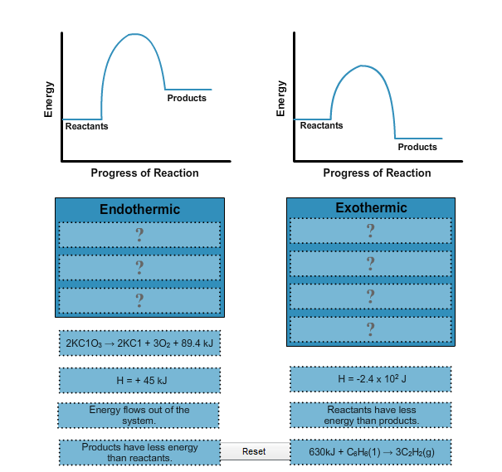

Resource Type: Interactive
Audience: Teachers and students in Chemistry
Subject: Science
Grade / Course: Chemistry
Student Expectations: C.11D Science concepts. The student understands the energy changes that occur in chemical reactions. The student is expected to perform calculations involving heat, mass, temperature change, and specific heat.

Topic / Tag: Source: energy, chemical reactions, endothermic, exothermic
TEA Approved: Yes
License: Free and available for all public school teachers and students in Texas through TEA’s LMS portal
Content:
Label | Ownership | Type | Location (url)
Content 1 | TEA/University of Texas at Austin | Interactive | http://www.ontrack-media.net/chemistry/cm4l9interactive1.html
Related Resources:
Title | Video url | Doc url | Link
Resource 1 |  |  | http://www.wisc-online.com/Objects/ViewObject.aspx?ID=GCH8805
Resource 2 |  |  | http://chemwiki.ucdavis.edu/Physical_Chemistry/Chemical_Equilibrium/Effect_Of_Temperature_On_Equilibrium_Composition/Exothermic_Versus_Endothermic_And_K

