Resource Build Template World History

Resource Title: OnTRACK for College Readiness World History- Module 4, Lesson 2- The Hellenistic Age
Brief Description (one to three sentences):
Given information about Alexander the Great and the Hellenistic Empire, students will create a concept map that summarizes the new ideas that spread throughout the Hellenistic world.
Thumbnail (file name and location): Please use the logo found in iTunes U
OnTRACK for College Readiness: World History – Module 4, Lesson 2-Section 3-
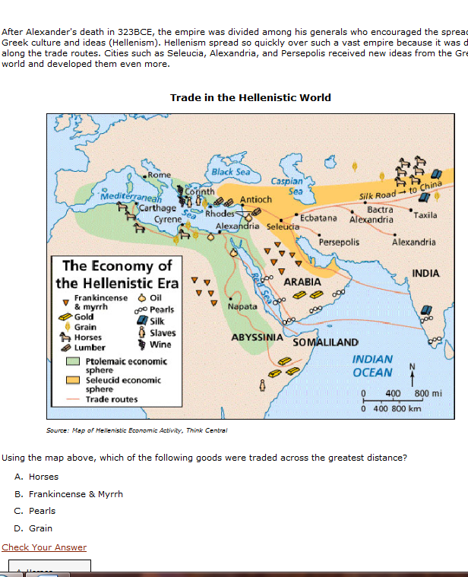
Resource Type: Html text, image, and http://ontrack-media.net/worldhistory/whm4l2s1a.html
Audience: Teachers and students in World History
Subject: Social Studies
Grade/ Course: World History
Student Expectations: WH (27) (A) Science, technology, and society. The student understands how major scientific and mathematical discoveries and technological innovations affected societies prior to 1750. The student is expected to identify the origin and diffusion of major ideas in mathematics, science, and technology that occurred in river valley civilizations, classical Greece and Rome, classical India, and the Islamic caliphates between 700 and 1200 and in China from the Tang to Ming dynasties.

Topic/Tag: Hellenistic, Greek, Alexander the Great, Philosophy, Astronomy
Source: OnTRACK for College Readiness: World History
TEA Approved: Yes
License: Free and available for all public school teachers and students in Texas through TEA’s LMS portal

Content:
Label | Ownership | Type | Location (url)
Content 1 | TEA/University of Texas at Austin | Interactive | Module 4, Lesson 2-Section 3- text, map and interactive question.  Image: http://www.ontrack-media.net/worldhistory/whm4l2image5.jpg  Interactive question:  http://ontrack-media.net/worldhistory/whm4l2s1a.html
Content 2

Related Resources:
Title | Video url | Doc url | Link
Resource 1 |  |  | http://ontrack-media.net/worldhistory/whm4l2animation1mobile.html
Resource 2 |  |  | http://ontrack-media.net/worldhistory/whm4l2s2a.html
Resource 3
Resource 4

