Resource Build Template Physics

Resource Title: OnTRACK for College Readiness Physics

Brief Description (one to three sentences): Given diagrams, illustrations, and graphs, students will predict image formations resulting from reflection on a plane mirror.

Thumbnail (file name and location): Please use the logo found in iTunes U
OnTRACK for College Readiness: Physics, Module 4, Lesson 6, Section #3
http://www.ontrack-media.net/physics/pm4l6slideshow.swf
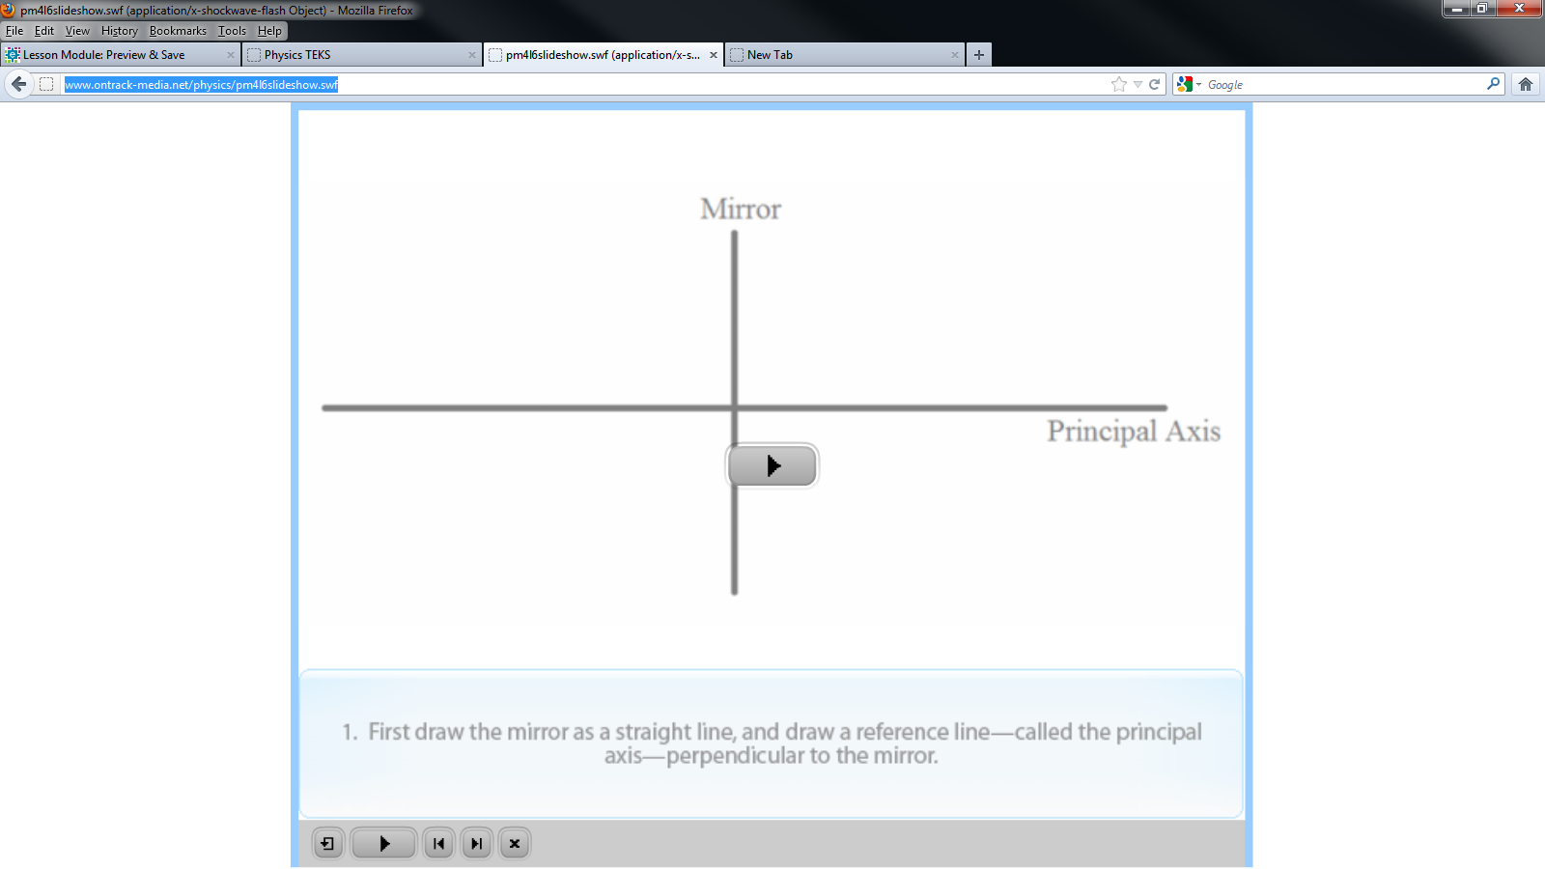
Resource Type: Video (Slide Show)

Audience: Teachers and students in Physics

Subject: Physics

Grade / Course: Physics

Student Expectations: P7(E) describe and predict image formation as a consequence of reflection from a plane mirror and refraction through a thin convex lens

Topic / Tag: reflection, plane mirror, refraction, convex lens

Source: OnTRACK for College Readiness: Physics

TEA Approved: Yes

License: Free and available for all public school teachers and students in Texas through TEA’s LMS portal

Content:
Label | Ownership | Type | Location (url)
Content 1 | TEA/University of Texas at Austin | Video-slideshow | http://www.ontrack-media.net/physics/pm4l6slideshow.html

Related Resources:
Title | Video url | Doc url | Link
Resource 1 |  |  | http://www.physicsclassroom.com/Class/refln/u13l2b.cfm
Resource 2 |  |  | http://www.physicsclassroom.com/Class/refln/U13L2c.cfm
Resource 3
Resource 4

