Resource Build Template Physics

Resource Title: OnTRACK for College Readiness Physics: Gravitational Force
Brief Description (one to three sentences): Given diagrams, descriptions, and/or illustrations, students will calculate the gravitational force between two objects

Thumbnail (file name and location): Please use the logo found in iTunes U
OnTRACK for College Readiness: Physics, Module 2, Lesson 2, Section 1 & 4
http://www.epsilen.com/Course/Private/Master/Index.aspx
HTML Text
The Law of Gravitation is an inverse-square law. Look at the formula F_{g} = G m₁m_{2/} d² , F is on one side, and d is on the other side squared and on the bottom of the fraction. It means that as the distance between two objects increases, the force of gravity between them decreases by the SQUARE of the distance. Also, if the distance decreases, the force of gravity will increase by the SQUARE of the distance between them. If I double my distance, I have ¼ the force of gravitation, and if I triple it, I have 1/9 the force. If I cut my distance in half, I have 4 times the force of gravitation, and if I cut it to 1/3, I have 9 times the force.

Image

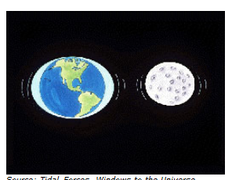

Resource Type: HTML text and Images
Audience: Teachers and students in Physics
Subject: Science
Grade / Course: Physics
Student Expectations: P.5B Science concepts. The student knows the nature of forces in the physical world. The student is expected to describe and calculate how the magnitude of the gravitational force between two objects depends on their masses and the distance between their centers.

Topic / Tag: Source: gravitational force, mass, distance
TEA Approved: Yes
License: Free and available for all public school teachers and students in Texas through TEA’s LMS portal
Content:
Label | Ownership | Type | Location (url)
Content 1 | TEA/University of Texas at Austin | HTML Text | See above
 | TEA/University of Texas at Austin | Image | http://www.ontrack-media.net/physics/pm2l2image3.jpg
Related Resources:
Title | Video url | Doc url | Link
Resource 1 |  |  | http://hyperphysics.phy-astr.gsu.edu/hbase/hframe.html
Resource 2 |  |  | http://hubblesite.org/explore_astronomy/black_holes/encyclopedia.html

