Resource Build Template Physics

Resource Title: OnTRACK for College Readiness Physics Scientific Process: Scientific Methods: Data Analysis
Brief Description (one to three sentences): Given laboratory investigation data in the form of tables, charts, and graphs, students will analyze and predict trends from the data and solve mathematically.

Thumbnail (file name and location): Please use the logo found in iTunes U
OnTRACK for College Readiness: Physics, Module 0, Lesson 11, Section 1
http://www.epsilen.com/Course/Private/Master/Index.aspx
HTML text
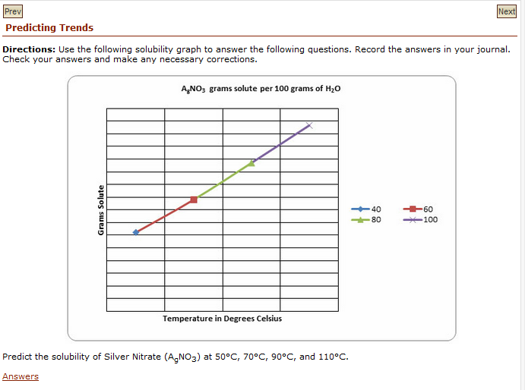
Resource Type: Html text and images
Audience: Teachers and students in Physics
Subject: Science
Grade / Course: Physics
Student Expectations: (3) Scientific processes. The student uses critical thinking, scientific reasoning, and problem solving to make informed decisions within and outside the classroom. The student is expected to:
(F) express and interpret relationships symbolically in accordance with accepted theories to make predictions and solve problems mathematically, including problems requiring proportional reasoning and graphical vector addition.

Topic / Tag: inference, investigation, data, trend
Source: OnTRACK for College Readiness: Physics
TEA Approved: Yes
License: Free and available for all public school teachers and students in Texas through TEA’s LMS portal
Content:
Label | Ownership | Type | Location (url)
Content 1 | TEA/University of Texas at Austin | HTML text including images listed below | Physics, Module 0, Lesson 11, Section 3
 | TEA/University of Texas at Austin | Image | http://ontrack-media.net/science/sm0l11image19.jpg
Related Resources:
Title | Video url | Doc url | Link
Resource 1 |  |  | http://www.figurethis.org/challenges/c29/challenge.htm
Resource 2 |  |  | http://www.shodor.org/interactivate/activities/BarGraph/

