Resource Build Template Physics

Resource Title: OnTRACK for College Readiness Physics: Scientific Processes-Scientific Methods- Equipment for Physics
Brief Description (one to three sentences): Given laboratory investigation scenarios, students will determine the equipment that best fits the procedure.

Thumbnail (file name and location): Please use the logo found in iTunes U
OnTRACK for College Readiness: Physics, Module 0, Lesson 8, Section 1
http://www.epsilen.com/Course/Private/Master/Index.aspx
Interactive

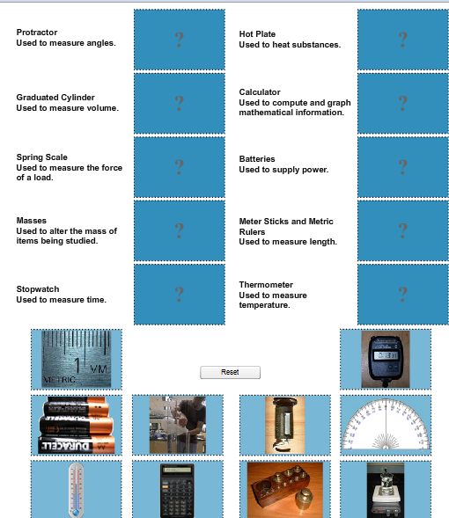
Resource Type: Interactive
Audience: Teachers and students in Physics
Subject: Science
Grade / Course: Physics
Student Expectations: P.2G Scientific processes. The student uses a systematic approach to answer scientific laboratory and field investigative questions. The student is expected to use a wide variety of additional course apparatus, equipment, techniques, materials, and procedures as appropriate such as ripple tank with wave generator, wave motion rope, micrometer, caliper, radiation monitor, computer, ballistic pendulum, electroscope, inclined plane, optics bench, optics kit, pulley with table clamp, resonance tube, ring stand screen, four inch ring, stroboscope, graduated cylinders, and ticker timer;

Topic / Tag: Source: physics, equipment, scientific methodology
TEA Approved: Yes
License: Free and available for all public school teachers and students in Texas through TEA’s LMS portal
Content:
Label | Ownership | Type | Location (url)
Content 1 | TEA/University of Texas at Austin | Interactive | http://www.ontrack-media.net/physics/pm0l8interactive1.swf
Related Resources:
Title | Video url | Doc url | Link
Resource 1 |  |  | http://demoroom.physics.ncsu.edu/cgi-bin/top25.cgi
Resource 2 | http://www.teachertube.com/viewVideo.php?video_id=115767

