Resource Build Template World Geography

Resource Title: OnTRACK for College Readiness World Geography
Brief Description (one to three sentences): Given a world population map and a world climate map, students will draw conclusions about the climate zones that are most favorable to humans and will present their findings in the form of a circle graph.
Thumbnail (file name and location): Please use the logo found in iTunes U
OnTRACK for College Readiness: World Geography, Module 4, Lesson 4, Climate Zones and Adaptation (section 2)
Images 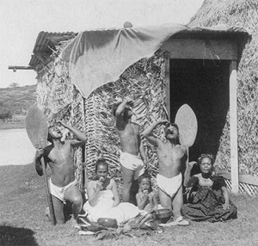 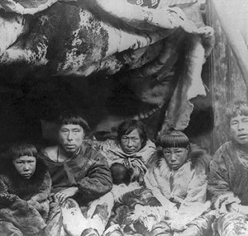
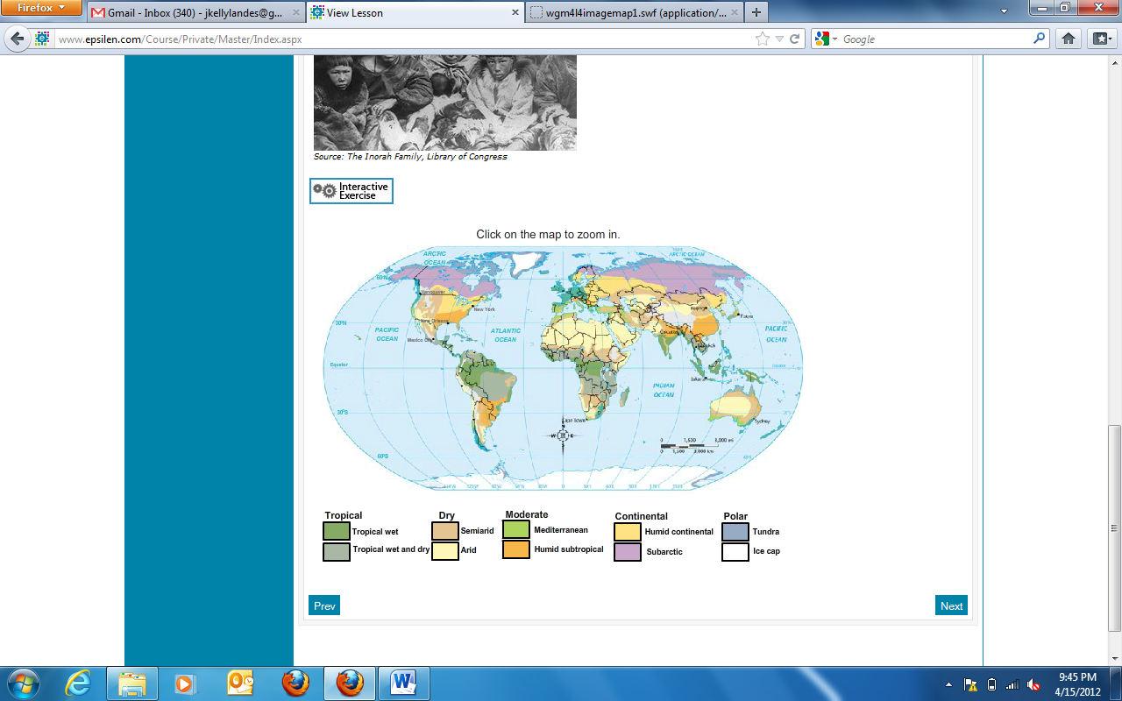
Resource Type: Image and Interactive
Audience: Teachers and students in World Geography
Subject: Social Studies
Grade / Course: World Geography
Student Expectations: WG (6)(A)Geography. The student understands the types and patterns of settlement, the factors that affect where people settle, and processes of settlement development over time. The student is expected to locate settlements and observe patterns in the size and distribution of cities using maps, graphics, and other information.
Topic / Tag: settlement, resources, population growth, climate

Source: OnTRACK for College Readiness: World Geography
TEA Approved: Yes
License: Free and available for all public school teachers and students in Texas through TEA’s LMS portal

Content:
Label | Ownership | Type | Location (url)
Content 1 | TEA/University of Texas at Austin | Images | http://www.ontrack-media.net/worldgeography/wgm4l4image3.jpg  http://www.ontrack-media.net/worldgeography/wgm4l4image4.jpg
Content 2 |  | Interactive | http://www.ontrack-media.net/worldgeography/wgm4l4imagemap1.html

Related Resources:
Title | Video url | Doc url | Link
Resource 1 | http://www.youtube.com/watch?v=U_c48qvxFqg
Resource 2 |  |  | http://www.ontrack-media.net/worldgeography/wgm4l4imagemap2.html
Resource 3
Resource 4

