Resource Build Template World Geography

Resource Title: OnTRACK for College Readiness World Geography
Brief Description (one to three sentences): Given a map of the world’s major cities and a world physical map, students will compare and analyze the maps to determine physical features that are common among the world’s major cities.
Thumbnail (file name and location): Please use the logo found in iTunes U
OnTRACK for College Readiness: World Geography, Module 4, Lesson 3, Processing/Assessment – Applying Concepts(section 3)
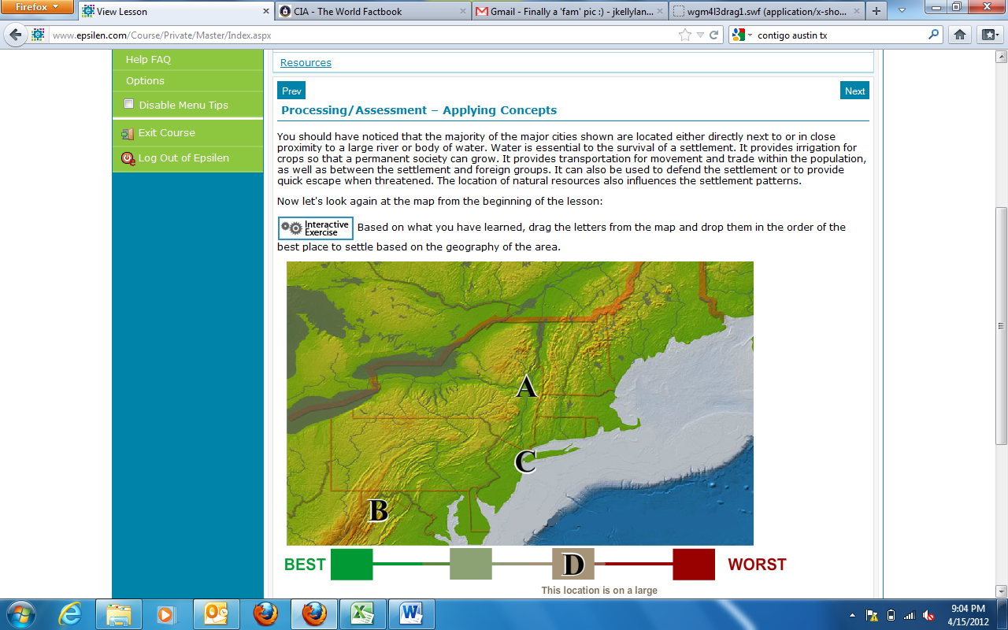
Resource Type: HTML Text and Interactive
Audience: Teachers and students in World Geography
Subject: Social Studies
Grade / Course: World Geography
Student Expectations: WG (6)(A)Geography. The student understands the types and patterns of settlement, the factors that affect where people settle, and processes of settlement development over time. The student is expected to locate settlements and observe patterns in the size and distribution of cities using maps, graphics, and other information.
Topic / Tag: settlement, resources, population growth

Source: OnTRACK for College Readiness: World Geography
TEA Approved: Yes
License: Free and available for all public school teachers and students in Texas through TEA’s LMS portal

Content:
Label | Ownership | Type | Location (url)
Content 1 | TEA/University of Texas at Austin | HTML Text from World Geography Module 4, Lesson 3, section 3 | See screenshot above
 | TEA/University of Texas at Austin | Interactive | http://www.ontrack-media.net/worldgeography/wgm4l3drag1.html

Related Resources:
Title | Video url | Doc url | Link
Resource 1 | http://www.youtube.com/watch?v=gOU9DF1eTH8
Resource 2 |  |  | http://www.ontrack-media.net/worldgeography/wgm4l3interactive1.html
Resource 3
Resource 4

