Resource Build Template World Geography

Resource Title: OnTRACK for College Readiness World Geography- Settlement Patterns and Climate
Brief Description (one to three sentences): Given a world population map and a world climate map, students will draw conclusions about the climate zones that are most favorable to humans and will present their findings in the form of a circle graph.
Thumbnail (file name and location): Please use the logo found in iTunes U
OnTRACK for College Readiness: World Geography, Module 4, Lesson 4, section 2 HTML text and interactive
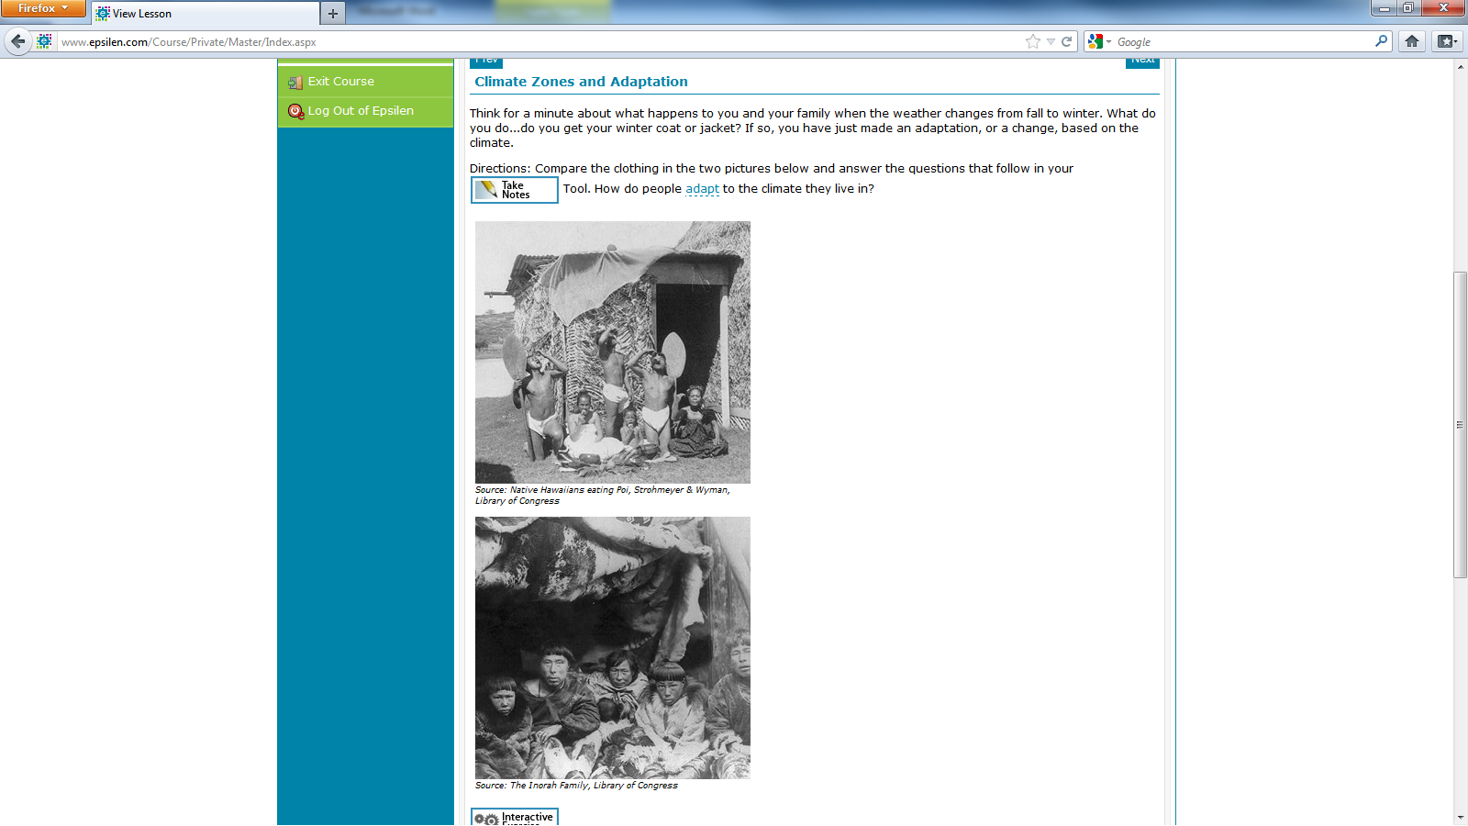

http://ontrack-media.net/worldgeography/wgm4l4imagemap1mobile.html
Resource Type: HTML Text and interactive

Audience: Teachers and students in World Geography
Subject: Social Studies
Grade/ Course: World Geography
Student Expectations: WG(21)(C) Social studies skills. The student applies critical-thinking skills to organize and use information acquired from a variety of valid sources, including electronic technology. The student is expected to create and interpret different types of maps to answer geographic questions, infer relationships, and analyze change.
Topic/Tag: Population distribution, population density, physical geography
Source: OnTRACK for College Readiness: World Geography
TEA Approved: Yes
License: Free and available for all public school teachers and students in Texas through TEA’s LMS portal

Content:
Label | Ownership | Type | Location (url)
Content 1 | TEA/University of Texas at Austin | HTML Text | See Screenshot
Content 2 |  | Interactive | http://ontrack-media.net/worldgeography/wgm4l4imagemap1mobile.html

Related Resources:
Title | Video url | Doc url | Link
Resource 1 | http://www.youtube.com/watch?feature=player_embedded&v=U_c48qvxFqg
Resource 2 |  |  | http://ontrack-media.net/worldgeography/wgm4l4quizmobile.html
Resource 3
Resource 4

