Resource Build Template World Geography

Resource Title: OnTRACK for College Readiness World Geography-Interdependence/Globalization
Brief Description (one to three sentences):
After watching a video on what globalization really means, students will be able to give examples of how regions around the world communicate, transport, and trade and the effects it has on how we view different cultures.
Thumbnail (file name and location): Please use the logo found in iTunes U
OnTRACK for College Readiness: World Geography, Module 2, Lesson 7, Section 1
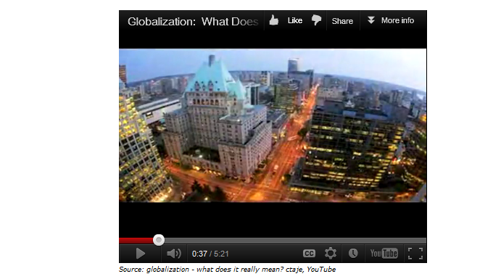
Resource Type: Video
Audience: Teachers and students in World Geography
Subject: Social Studies
Grade / Course: World Geography
Student Expectations: WG (16)(B) Culture. Give examples of ways various groups of people view cultures, places, and regions differently.
Topic / Tag: globalization, interdependence, culture, transport, trade
Source: OnTRACK for College Readiness: World Geography
TEA Approved: Yes
License: Free and available for all public school teachers and students in Texas through TEA’s LMS portal
Content:
Label | Ownership | Type | Location (url)
Globalization – What does it really mean? | You Tube | Video | http://www.youtube.com/watch?feature=player_embedded&v=LtmvksvSvtc#!

Related Resources:
Title | Video url | Doc url | Link
Did You Know; Shift Happens - Globalization; Information Age | http://www.youtube.com/watch?v=ljbI-363A2Q&feature=related
Resource 2 |  |  | http://www.ontrack-media.net/worldgeography/wgm2l7s1quiz.html
Resource 3
Resource 4

