Resource Build Template World Geography

Resource Title: OnTRACK for College Readiness World Geography
Brief Description (one to three sentences): Given information about the colonization of Africa, students will analyze the effects of colonization and will describe the impact of these effects on African society today.
Thumbnail (file name and location): Please use the logo found in iTunes U
OnTRACK for College Readiness: World Geography, Module 6, Lesson 5, Introduction: Colonization of Africa (section 1)
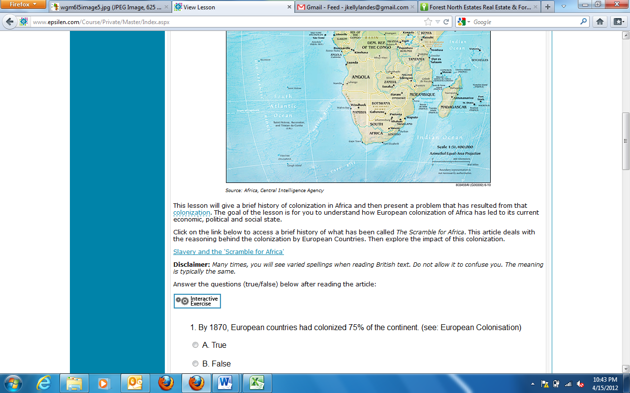
Resource Type: Map and HTML text
Audience: Teachers and students in World Geography
Subject: Social Studies
Grade / Course: World Geography
Student Expectations: WG (14)(B) Government. The student understands the geographic processes that influence political divisions, relationships, and policies. The student is expected to explain how forces of conflict and cooperation influence the allocation of control of Earth's surface such as the formation of congressional voting districts or free trade zones.
Topic / Tag: government, colonization, policy

Source: OnTRACK for College Readiness: World Geography
TEA Approved: Yes
License: Free and available for all public school teachers and students in Texas through TEA’s LMS portal

Content:
Label | Ownership | Type | Location (url)
Content 1 | TEA/University of Texas at Austin | Html text | WGM6L5Section2, all questions and answers just after map
Content 2 | Central Intelligence Agency | map | http://www.ontrack-media.net/worldgeography/wgm6l5image4.jpg

Related Resources:
Title | Video url | Doc url | Link
Resource 1 |  |  | http://www.nytimes.com/2004/07/16/world/devastated-by-aids-africa-sees-life-expectancy-plunge.html
Resource 2 | http://www.pbs.org/wnet/wideangle/episodes/aids-warriors/video-full-episode/4799/
Resource 3
Resource 4

