Resource Build Template Biology

Resource Title: OnTRACK for College Readiness Biology
Brief Description (one to three sentences): Thumbnail (file name and location):
Biology, Module 3, Lesson 5 - Given examples or descriptions, students will determine taxonomic relationships based on similarities and differences among groups.

Resource Type: Interactive – Flashcards and Scatter game
Audience: Teachers and students in Biology
Subject: Biology
Grade / Course: Biology
Student Expectations: B 8 B)
The student knows that taxonomy is a branching classification based on the shared characteristics of organisms and can change as new discoveries are made. The student is expected to:
(B) categorize organisms using a hierarchical classification system based on similarities and differences shared among groups;

Topic / Tag: categorize, taxonomy, hierarchy, classification
Source: OnTRACK for College Readiness: Biology
TEA Approved: Yes
License: Free and available for all public school teachers and students in Texas through TEA’s LMS portal
Content:
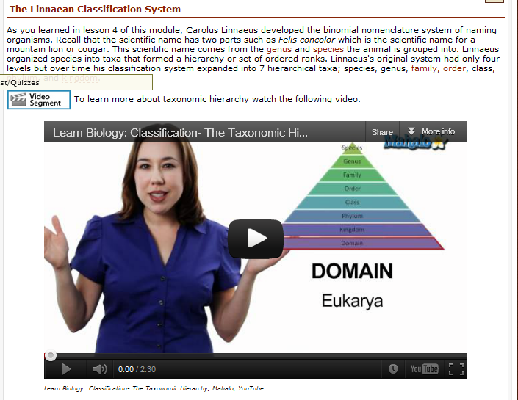

Label | Ownership | Type | Location (url)
Content 1 | Youtube | Video | http://www.youtube.com/watch?feature=player_embedded&v=kKwOlAqQoLk
Content 2

Related Resources:
Title | Video url | Doc url | Link
Resource 1 | http://www.youtube.com/watch?v=iyAOkzdO3vw&feature=related
Resource 2 |  |  | http://evolution.berkeley.edu/evolibrary/article/0_0_0/evo_toc_01

