Resource Build Template Biology

Resource Title: OnTRACK for College Readiness Biology: Taxonomy- Major Groups
Brief Description (one to three sentences): Given illustrations or descriptions, students will determine the classification of the kingdoms including archaea, bacteria, protists, fungi, plants, and animals.

Thumbnail (file name and location): Please use the logo found in iTunes U
OnTRACK for College Readiness: Biology, Module 3, Lesson 6, Sections 4 and 5
http://www.epsilen.com/Course/Private/Master/Index.aspx
Interactive
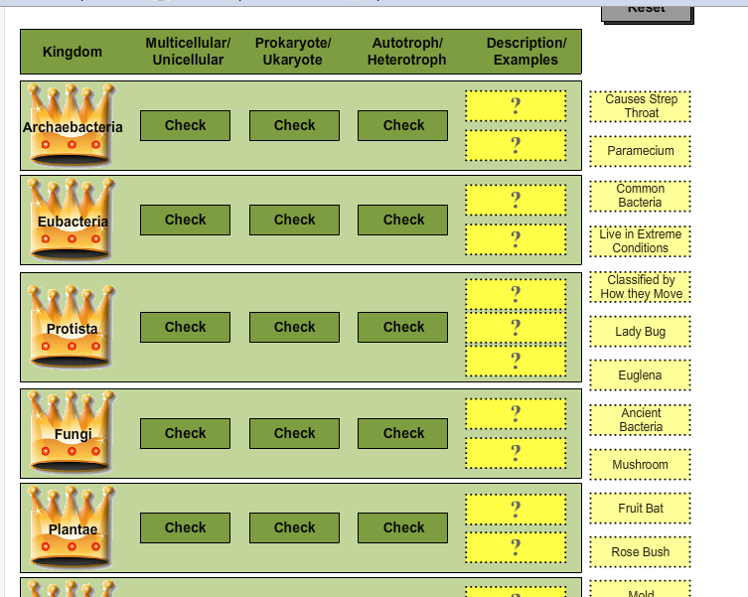

Resource Type: Interactive
Audience: Teachers and students in Biology
Subject: Science
Grade / Course: Biology
Student Expectations: Bio8.C Science concepts. The student knows that taxonomy is a branching classification based on the shared characteristics of organisms and can change as new discoveries are made. The student is expected to: compare characteristics of taxonomic groups, including archaea, bacteria, protists, fungi, plants, and animals.

Topic / Tag: taxonomy, kingdom, organism, classification
Source: OnTRACK for College Readiness: Biology
TEA Approved: Yes
License: Free and available for all public school teachers and students in Texas through TEA’s LMS portal
Content:
Label | Ownership | Type | Location (url)
Content 1 | TEA/University of Texas at Austin | Interactive | http://www.ontrack-media.net/biology/bm3l6interactive1.html
Related Resources:
Title | Video url | Doc url | Link
Resource 1 |  |  | http://www.ric.edu/faculty/ptiskus/six_kingdoms/index.htm
Resource 2 |  |  | http://www.ontrack-media.net/biology/bm3l6interactive2.html
Resource 3 |  |  | http://www.studystack.com/flashcard-92915

