Resource Build Template Biology

Resource Title: OnTRACK for College Readiness Biology
Brief Description (one to three sentences): Thumbnail (file name and location):
Biology, Module 3, Lesson 5 section three- Given examples or descriptions, students will determine taxonomic relationships based on similarities and differences among groups.

Resource Type: Interactive – Flashcards and Scatter game
Audience: Teachers and students in Biology
Subject: Biology
Grade / Course: Biology
Student Expectations: B 8 B)
The student knows that taxonomy is a branching classification based on the shared characteristics of organisms and can change as new discoveries are made. The student is expected to:
(B) categorize organisms using a hierarchical classification system based on similarities and differences shared among groups;

Topic / Tag: categorize, taxonomy, hierarchy, classification
Source: OnTRACK for College Readiness: Biology
TEA Approved: Yes
License: Free and available for all public school teachers and students in Texas through TEA’s LMS portal
Content: 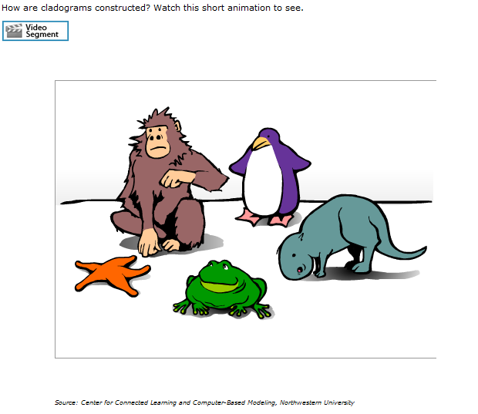
Label | Ownership | Type | Location (url)
Content 1 | Center for Connected Learning and Computer Based Modeling, Northwestern University | Video | http://ccl.northwestern.edu/simevolution/obonu/cladograms/HowToBuildACladogram.swf
Content 2

Related Resources:
Title | Video url | Doc url | Link
Resource 1 |  |  | http://www.wellcometreeoflife.org/interactive/
Resource 2 |  |  | http://www.ucmp.berkeley.edu/education/explorations/tours/Trex/index.html

