Resource Build Template Biology

Resource Title: OnTRACK for College Readiness Biology
Brief Description (one to three sentences):
Given descriptions or illustrations of molecular transport, students will identify the type of molecular movement in or out of the cell.

Thumbnail (file name and location): Please use the logo found in iTunes U
OnTRACK for College Readiness: Biology, Module 1, Lesson 5, sections # 3 and 4

Respiration: Step 2 Krebs Cycle
http://www.ontrack-media.net/biology/bm1l5video3.swf

Respiration Step 3: ETC and ATP synthesis
http://www.ontrack-media.net/biology/bm1l5video4.swf
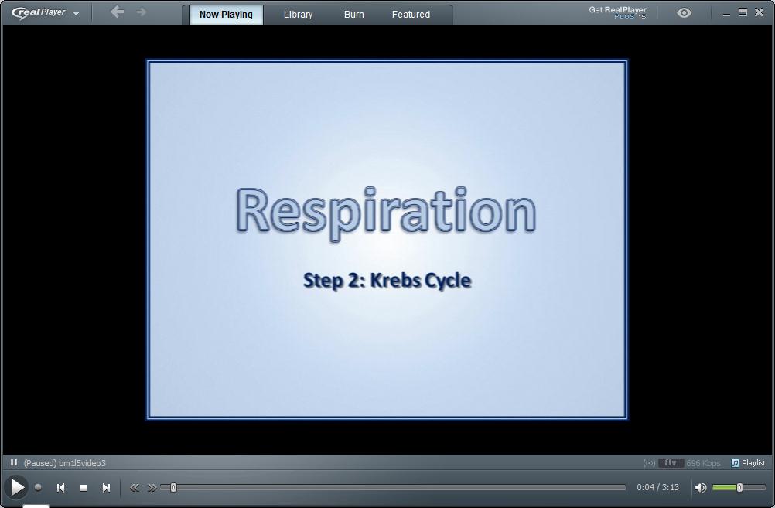
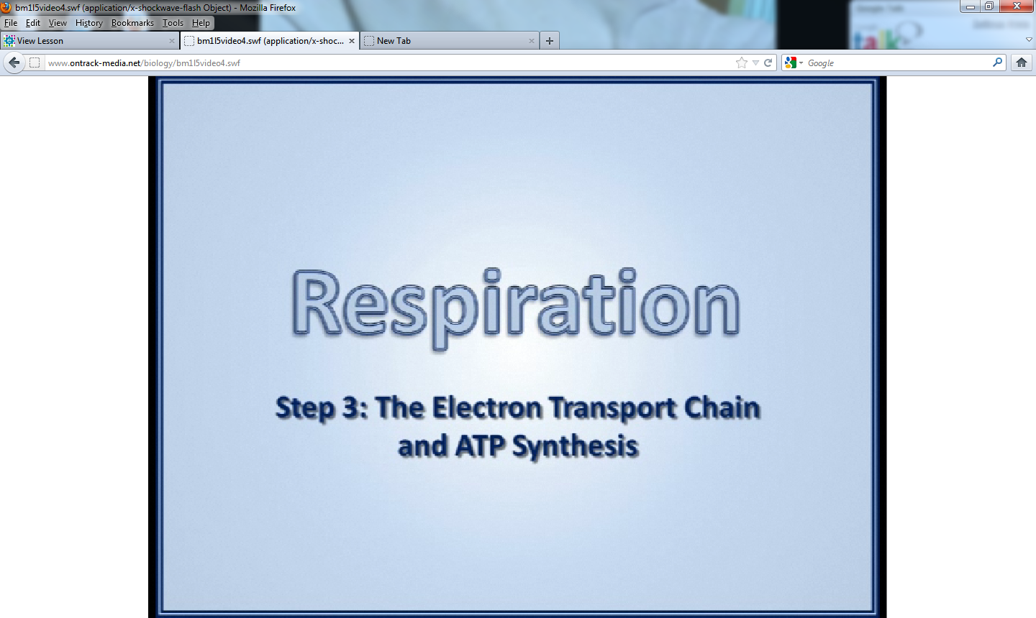

Resource Type: Videos
Audience: Teachers and students in Biology
Subject: Biology
Grade / Course: Biology
Student Expectations: B4B investigate and explain cellular processes, including homeostasis, energy conversions, transport of molecules, and synthesis of new molecules

Topic / Tag: homeostasis, cellular processes, energy conversions, respiration

Source: OnTRACK for College Readiness: Biology

TEA Approved: Yes

License: Free and available for all public school teachers and students in Texas through TEA’s LMS portal

Content:
Label | Ownership | Type | Location (url)
Content 1 | TEA/University of Texas at Austin | video | http://www.ontrack-media.net/biology/bm1l5video3.html
Content 2 | TEA/University of Texas at Austin | video | http://www.ontrack-media.net/biology/bm1l5video4.html

Related Resources:
Title | Video url | Doc url | Link
Resource 1 |  |  | http://www.ontrack-media.net/biology/bm1l5drag3.html
Resource 2 |  |  | http://www.ontrack-media.net/biology/bm1l5drag4.html
Resource 3
Resource 4

