Resource Build Template Biology

Resource Title: OnTRACK for College Readiness Biology

Brief Description (one to three sentences): Given choices of natural resources and lab materials, students will select disposal and recycling methods that best conserve and protect our resources.
Thumbnail (file name and location): Please use the logo found in iTunes U
OnTRACK for College Readiness: Biology, Module 0, Lesson 3, section 4

http://www.ontrack-media.net/science/sm0l3interactive2.swf

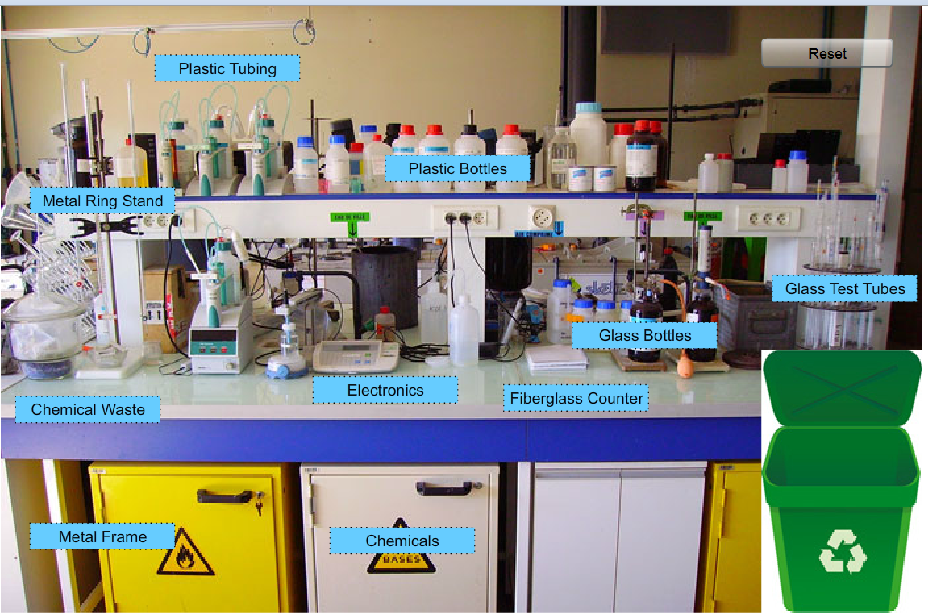

Resource Type: Interactive

Audience: Teachers and students in Biology

Subject: Biology

Grade / Course: Biology

Student Expectations: (B.1B) demonstrate an understanding of the use and conservation of resources and the proper disposal or recycling of materials.

Topic / Tag: conservation, resources, disposal, recycling

Source: OnTRACK for College Readiness: Biology

TEA Approved: Yes

License: Free and available for all public school teachers and students in Texas through TEA’s LMS portal

Content:
Label | Ownership | Type | Location (url)
Content 1 | TEA/University of Texas at Austin | interactive | http://www.ontrack-media.net/science/sm0l3interactive2.html
Related Resources:
Title | Video url | Doc url | Link
Resource 1 |  |  | http://www.epa.gov/wastes/conserve/materials/hhw.htm
Resource 2 |  |  | http://www.appropedia.org/Welcome_to_Appropedia
Resource 3
Resource 4

