Resource Build Template U.S. History

Resource Title: OnTRACK for College Readiness U.S. History, Module 2, Lesson 9, Wilson’s Fourteen Points
Brief Description (one to three sentences):
Given: (1) excerpts from Wilson’s Fourteen Points speech and (2) information about the Allied leaders’ reaction to the speech, students will summarize the important issues that were raised.
Thumbnail (file name and location): Please use the logo found in iTunes U
OnTRACK for College Readiness: U.S. History, Module 2, Lesson 9, Section 4- The World Responds, html text and image (bottom of page)
Resource Type: html text and image
President Woodrow Wilson awarded Nobel Peace Prize: 1919
For his peace-making efforts President Woodrow Wilson was awarded the 1919 Nobel Peace Prize.

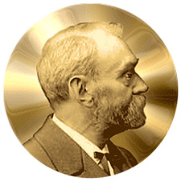
Audience: Teachers and students in U.S. History
Subject: Social Studies
Grade/ Course: U.S. History
Student Expectations: USH (24)(A) Citizenship. The student understands the importance of effective leadership in a constitutional republic. The student is expected to describe qualities of effective leadership.

Topic/Tag: Wilson’s Fourteen Points, Woodrow Wilson, Peace-making, leadership
Source: OnTRACK for College Readiness: U.S. History
TEA Approved: Yes
License: Free and available for all public school teachers and students in Texas through TEA’s LMS portal

Content:
Label | Ownership | Type | Location (url)
Content 1 | TEA/University of Texas at Austin | HTM text and image | Module 2, Lesson 9, Section 4- The World Responds, html text and image (bottom of page)
Content 2

Related Resources:
Title | Video url | Doc url | Link
Resource 1 |  |  | http://ontrack-media.net/ushistory/ushm2l9imagemap4mobile.html
Resource 2 |  |  | http://ontrack-media.net/ushistory/ushm2l9imagemap3mobile.html
Resource 3
Resource 4

