Resource Build Template World Geography

Resource Title: OnTRACK for College Readiness US History – Causes of the Great Depression
Brief Description (one to three sentences): Given graphs and/or statistical information about economic trends before and after the onset of the Great Depression, students will draw inferences and conclusions about its causes and effects.
Thumbnail (file name and location): Please use the logo found in iTunes U
OnTRACK for College Readiness: US History, Module 3, Lesson 1, Timeline (Section1)
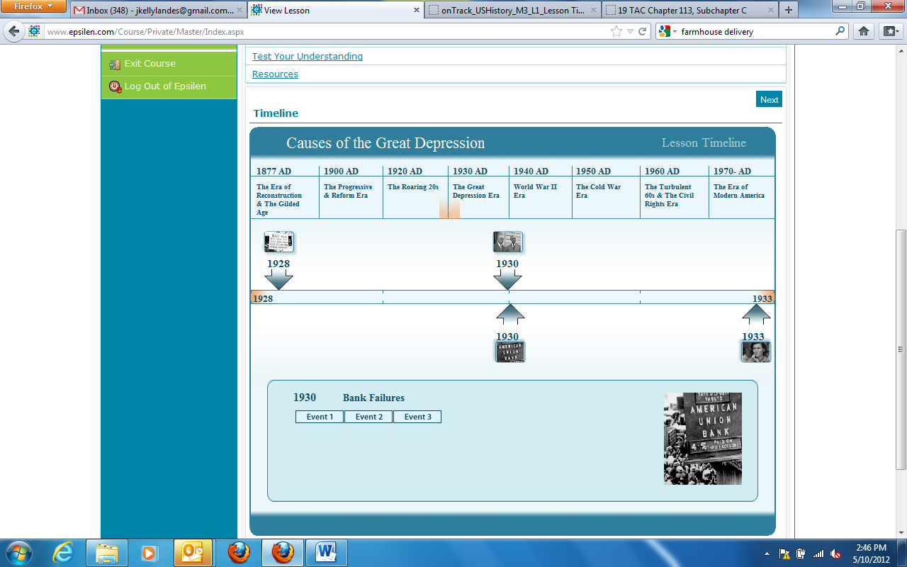
Resource Type: interactive
Audience: Teachers and students in US History
Subject: Social Studies
Grade/ Course: US History
Student Expectations: USH (16)(B) Economics. The student understands significant economic developments between World War I and World War II. The student is expected to identify the causes of the Great Depression, including the impact of tariffs on world trade, stock market speculation, bank failures, and the monetary policy of the Federal Reserve System.
Topic/Tag: Federal Reserve System, stock market, causes of Great Depression
Source: OnTRACK for College Readiness: US History
TEA Approved: Yes
License: Free and available for all public school teachers and students in Texas through TEA’s LMS portal
Content:
Label | Ownership | Type | Location (url)
Content 1 | TEA/University of Texas at Austin | Interactive | http://www.ontrack-media.net/ushistory/onTrack_USHistory_M3_L1_Lesson%20Timeline.html
Content 2

Related Resources:
Title | Video url | Doc url | Link
Resource 1 |  |  | http://www.ontrack-media.net/ushistory/ushm3l1drag2.html
Resource 2 |  |  | http://www.ontrack-media.net/ushistory/ushm3l1drag3.html
Resource 3
Resource 4

