Resource Build Template World Geography

Resource Title: OnTRACK for College Readiness US History – Japanese Internment
Brief Description (one to three sentences): Given a variety of sources of information about the internment of Japanese Americans during World War II, Students will: (1) explain why the United States government took these measures and (2) describe the impact on the lives of Japanese Americans.
Thumbnail (file name and location): Please use the logo found in iTunes U
OnTRACK for College Readiness: US History, Module 3, Lesson 8, Timeline (Section1)
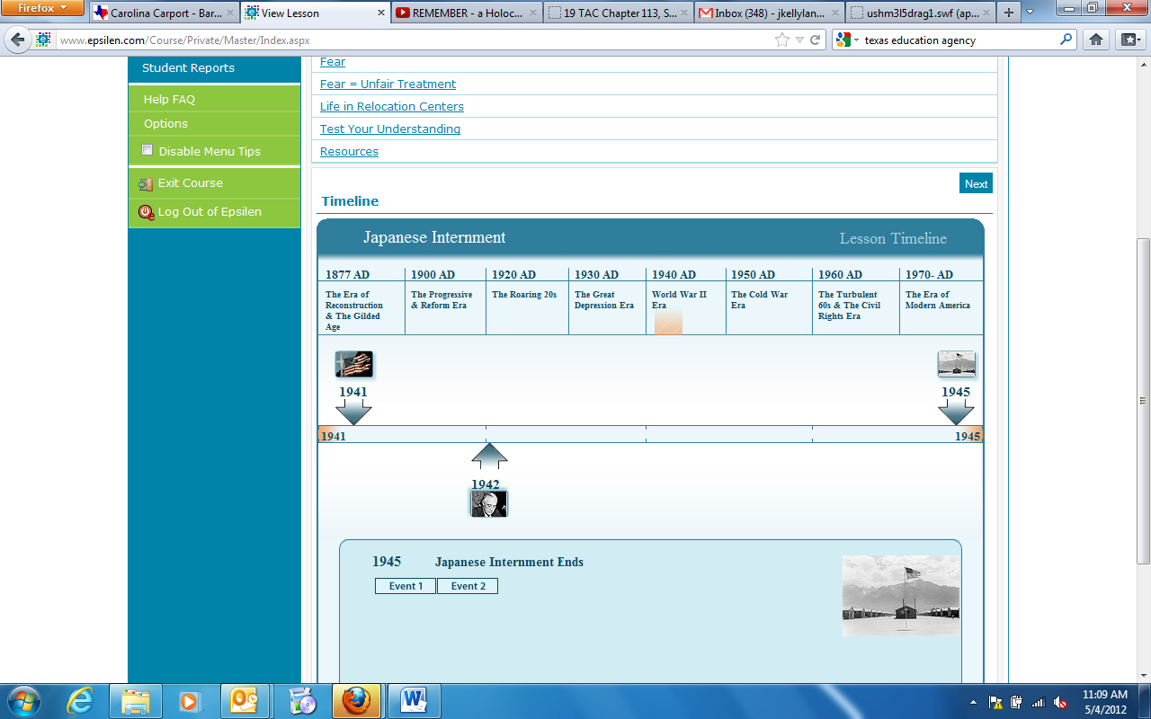
Resource Type: interactive
Audience: Teachers and students in US History
Subject: Social Studies
Grade/ Course: US History
Student Expectations: USH (7)(D) History. The student understands the domestic and international impact of U.S. participation in World War II. The student is expected to analyze major issues of World War II, including the Holocaust; the internment of German, Italian, and Japanese Americans and Executive Order 9066; and the development of conventional and atomic weapons.
Topic/Tag: timeline, united states history, Japanese internment
Source: OnTRACK for College Readiness: US History
TEA Approved: Yes
License: Free and available for all public school teachers and students in Texas through TEA’s LMS portal
Content:
Label | Ownership | Type | Location (url)
Content 1 | TEA/University of Texas at Austin | Interactive | http://www.ontrack-media.net/ushistory/onTrack_USHistory_M3_L8_Timeline.swf
Content 2

Related Resources:
Title | Video url | Doc url | Link
Resource 1 |  |  | http://www.ontrack-media.net/ushistory/ushm3l8animation1.html
Resource 2 |  |  | http://www.ontrack-media.net/ushistory/ushm3l8drag1.html
Resource 3
Resource 4

