Resource Build Template World Geography

Resource Title: OnTRACK for College Readiness US History – Progressive Era – The Need for Reform
Brief Description (one to three sentences): Given (1) broad categories that describe the major goals of the progressive movement (e.g. economic reform, moral reform, political reform, and promotion of social welfare) and (2) general information about selected issues of the late 1800s/early 1900s (e.g., child labor, working conditions, women's rights, food safety, temperance movement, etc.) students will categorize the issues according to corresponding progressive era goals.
Thumbnail (file name and location): Please use the logo found in iTunes U
OnTRACK for College Readiness: US History, Module 1, Lesson 2, Check Your Understanding, cont. (Section6)
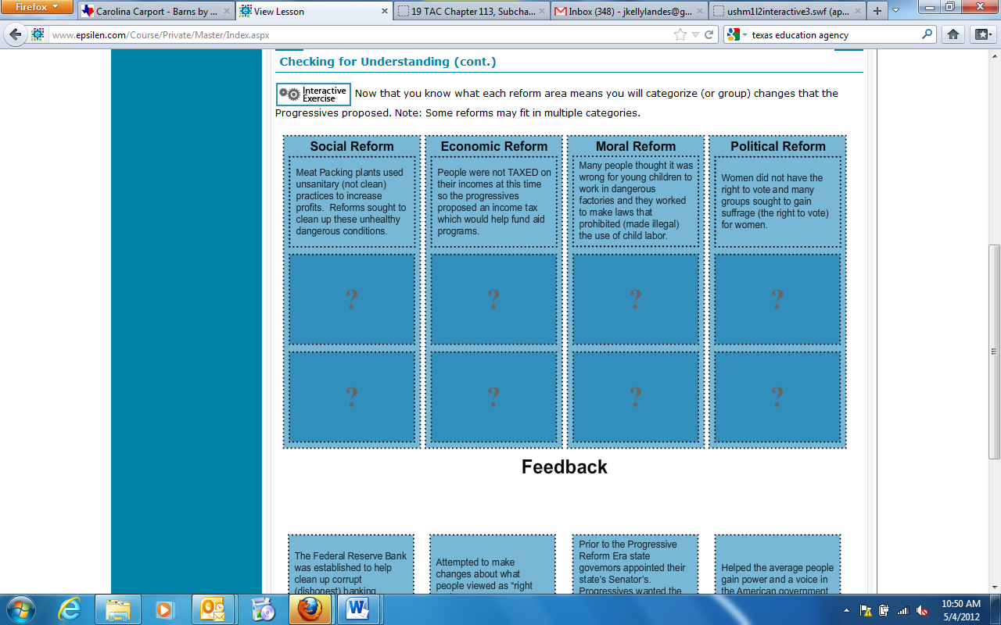
Resource Type: interactive
Audience: Teachers and students in US History
Subject: Social Studies
Grade/ Course: US History
Student Expectations: USH (3)(C) History. The student understands the political, economic, and social changes in the United States from 1877 to 1898. The student is expected to analyze social issues affecting women, minorities, children, immigrants, urbanization, the Social Gospel, and philanthropy of industrialists.
Topic/Tag: us history timeline, child labor, social changes, urbanization
Source: OnTRACK for College Readiness: US History
TEA Approved: Yes
License: Free and available for all public school teachers and students in Texas through TEA’s LMS portal

Content:
Label | Ownership | Type | Location (url)
Content 1 | TEA/University of Texas at Austin | Interactive | http://www.ontrack-media.net/ushistory/ushm1l2interactive3.html
Content 2

Related Resources:
Title | Video url | Doc url | Link
Resource 1 |  |  | http://www.ontrack-media.net/ushistory/USHistory_M5_L2_Timeline.swf
Resource 2 |  |  | http://www.ontrack-media.net/ushistory/ushm1l2interactive2.html
Resource 3
Resource 4

